Name: Akil Hosang

ID: 816003000

Course Name & Code: COMP 2606 – Software Engineering

Assignment 1

Year 2

Semester 2

Question 1

Functional requirements

* The system should read and record a user’s heart rate and blood pressure.
* The system should alert hospital when patient’s vitals go outside safe range.
* The system should detect when a patient is exercising and adjust the safe ranges accordingly.
* The system should check that the analog devices for measuring vital signs are working correctly and report failures to the hospital.
* Alert the owner when the battery life of the hardware is low.
* The system should allow an authorized user to adjust the patient’s safe ranges.

Non-Functional Requirements

* The system must reliable seeing that it must always be connected to the hospital to alert them when a patient may be in medical trouble.
* The system must be secure to keep all the patients documents confidential.
* Measures must be taken over a period of 1 minute
* The system must have a quick response time to be constantly collecting data from the patient and to immediately alert hospitals in case of abnormalities

Question 2

a) The customer is not an actor for the software to be developed. Even though the customer moves the items triggering the system to react, they do not directly interact with the information within the system.

b)

Actors:

RFID Reader System – Monitor the item count, adds to an item count, removes from an item count, alerts the manager an item is low in stock, alerts a manager an item is out of stock, displays the count of the items that have been restocked

Store Associate – Logs into the system, restocks an item and initiate a finish restock command.

Store Manager – Logs into the system, assigns a store associate to restock an item

Authenticator – Verifies the login credentials for the store manager and associate

c)

Use Case Id: UC1

Use case name: Login

Description: Authenticates the user and allows them to access the system

Related Requirements: REQ5, REQ7

Use Case Id: UC2

Use case name: Verify Login

Description: Authenticator verifies that the credentials provided match up to the authorized account credentials stored.

Related Requirements: REQ5, REQ7

Use Case Id: UC3

Use case name: Monitor count

Description: Checks RFID readers if the item count for an item has changed

Related Requirements: REQ1

Use Case Id: UC4

Use case name: Low stock

Description: When an item’s count goes below a set threshold, the manager is sent an email notifying them that the item is low in stock.

Related Requirements: REQ2, REQ4

Use Case Id: UC5

Use case name: Out of stock

Description: When an item’s count reaches zero, the manager is sent an email notifying them that the item is out of stock.

Related Requirements: REQ3, REQ4

Use Case Id: UC6

Use case name: Add Count

Description: Increments the count for an item

Related Requirements: REQ1

Use Case Id: UC7

Use case name: Remove count

Description: Decrements the count for an item

Related Requirements: REQ1

Use Case Id: UC8

Use case name: Assign restock

Description: Notify a store associate that a specific item/items need to be restocked via email.

Related Requirements: REQ5

Use Case Id: UC9

Use case name: Restock

Description: Records the amount of an item restocked by the store associate.

Related Requirements: REQ6, REQ7

Use Case Id: UC10

Use case name: Finish Restock

Description: Store associate alerts the system that the restocking process has ended

Related Requirements: REQ7

Use Case Id: UC11

Use case name: Display restock count

Description: Displays the item count obtained when restocking so that store associate can verify. Upon completion, notify manager.

Related Requirements: REQ7

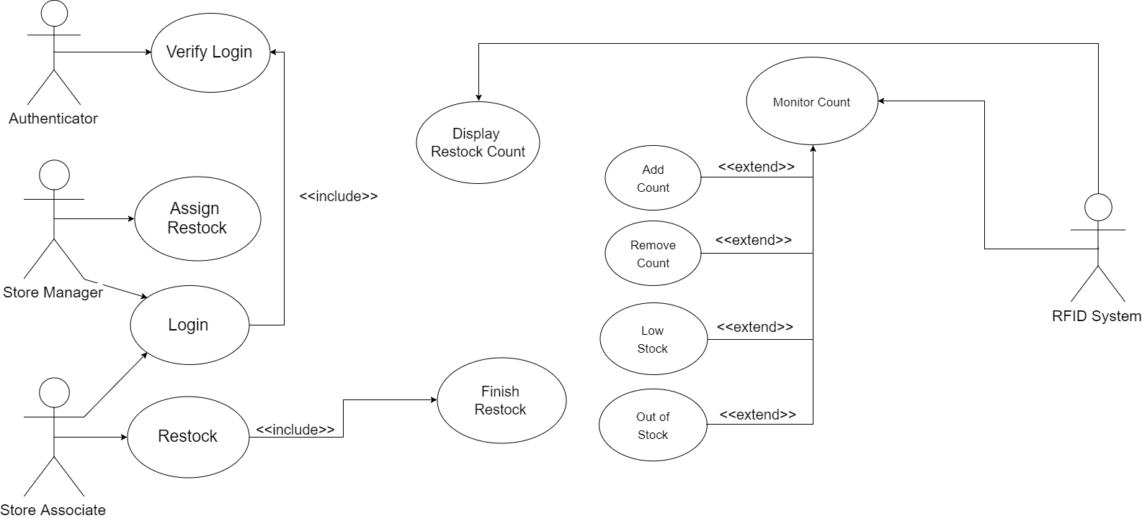

e) Additional requirements and use cases that can be added are:

* When an item’s count reaches zero, alert the provider for that item to prepare orders for the item unless assigned to do otherwise.
* The system should allow a manager to see statistics on the items in the system
* The system should allow a manager to view the number of tasks assigned to employees